

NEVADA COUNTY
wOMEN’S SOCIAL CLUB

MAY 2026

Ladies,

Another year and another fabulous fashion show!!!! Kudos to Liz, Mary, Karen and all their helpers. I know many discussions have taken place about whether we want Whim to handle this event for us or enlist J. Breuer, Yuba Blue and Penney’s, along with Whim. While it is much easier on our Club to pass it over to Whim, I believe much of our membership enjoys seeing fashions from a variety of stores. A big thank you goes out to the models, Kathryn, Joan, Rose, Susan, Sandy, Lynnel, Gillian, Tami and Carol for a great job. Carol, even with her shoe mishap, never missed a beat as she rallied and finished her sweep in bare feet!

The raffle was a huge success, especially with our new tickets Stacey instituted. Our gross take was almost $1600. After we cover all our expenses, any proceeds will go to the general fund.

The ambience of the room at the Lake of the Pines was a perfect setting, even if I couldn’t see a single face looking out toward the windows! We are always looking for new venues, and our May and June events reflect Karen’s creativity. In May we return to Las Katarina’s Mexican Restaurant, and in June we will be at Lilly’s Garden in Cedar Ridge. Both have limited seating so get your reservations in early.

It does take a village to organize our group. Please think about how you can be a leader in 2027 and get a hold of me or Linda M.

2026 Board Officers

c.canady@earthlink.net

https://www.newcomersnc.org

https://www.facebook.com
NewcomersNC/

President’s Message



MAY MEXICAN FIESTA

May 27, 2026
Check-in @ 10:30, lunch served at noon
Casa Las Katarinas, 10100 Alta Sierra Dr., Grass Valley
$30 per member, reservations limited to 80 attendees

Taco Bar with
Ground Beef and Grilled Chicken
Lettuce, Tomato, Cheese, Sour Cream
Corn and Flour Tortillas
Beans and Rice, Chips and Salsa
Rice Pudding
Soft Drinks, Tea and Coffee

Speaker: Terry McAteer, Board Member, Nevada County Historical Society



JUNE AFTERNOON SOCIAL
June 24, 4-6 pm. Check-in 3:30
Lily’s Garden Park, 12851 Highway 174, Cedar Ridge
Appetizers provided by Back Porch Market.
Water and lemonade provided, BYOB
$25/person. Reservations limited to 50 attendees
Parking is limited. Please carpool and park on the left side of lot. Additional parking is available on the adjacent property.
There are five acres of meandering paths, woodland nature trails, and a year-round stream. We will have our appetizers on the brick patio. Fun surprises to be announced.

ACTIVITY GROUPS
Girls Just Wanna Have Fun (GJWHF)

Dates and times depend on activity.

Adventure Gals
Dates and times depend on the activity.
Contact leader for more information.

Lunch Bunch
Date: 2nd Thursday (11:30)
Book Clubs
Cover Girls

, 2nd Wednesday (11:45)

Page Turners
Date: 3rd Wednesday (10:30)

Mysteries and More
Date: 1st Tuesday (1:30)



Garden Club
1st Tuesday, (11:00), location TBA

Short Walkers
2nd & 3rd Wednesday, locations will vary
Cooking Groups
Happy Cookers
3rd Monday, 10:00

Kitchen Kutups

Gourmet Girls
3rd Friday (10:30)
Bunco
2nd Tue (1:30), ASCC

Hand & Foot #1
2nd Monday (1:00)

Hand & Foot #2
3rd Monday (1:00)

Bridge
2nd Wednesday (10:30), Trailblazers, Alta Sierra Dr.

Mexican Train
4th Monday (12:00-2:00), Women’s Lounge, ASCC

Game Groups
News From the Activities Chair

The new groups, Bunco and Short Walkers, are still getting established. Bunco is currently looking for a consistent, long-term venue. If you have any suggestions, please reach out to Reine. For Short Walkers, Rose is continuing to build momentum. As a new member, she’s doing a wonderful job getting this group outdoors. If you’re interested in helping or co-leading, please consider reaching out to her.

With our New Member Welcome meeting this month, if you’re interested in starting a new cooking group, please let me know. Interest in a cooking group is consistently one of the most popular activities among new members.

As our new website is being developed, I’ll continue connecting with group leaders to explore ways—including the use of waitlists—to thoughtfully integrate both new and existing members into activity groups.
Thank you all for your continued support and dedication to making our activity groups so special!
Sandy Alves
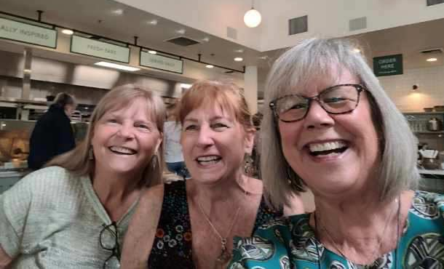

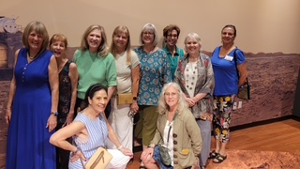

Don’t Miss the Next GJWHF Outing!
Wine tasting at Ciotti Cellars in Lincoln
Open to all Club Members

Thursday, May 21, 11:30 am
Ciotti Cellars at 3285 Crosby Herold Rd, Lincoln
$30 tasting includes 5 wines, 1 port, and charcuterie
PLUS 15% discount on all wine purchases.

To visit the winery website, click on the following link: http://www.ciotticellars.com
No refunds are available for this event, but you may transfer or sell your spot to another member if you cannot attend. We will set up carpooling after we have a headcount.

News From GJWHF
The GJWHF Club visited Sellands Cafe in March, before heading over to the Museum of Science and Curiosity. It was a great outing! Several girls enjoyed the early dinner out at 1849 brewery. Unfortunately, the trip to Crystal Hermitage Gardens was cancelled due to the early bloom. Plans for the rest of the year include:

May 21 - Wine tasting at Ciottti Cellars (see above for details)
June 9, 10 and 11 - trip to Guerneville (FULL)
July 7 - Happy hour and dinner at Maria’s Mexican Restaurant
July 16 - Lunch at High Hand Cafe in Loomis
August 19 - Pool party in Nevada City
September TBA - Off Broadstreet play in Nevada City
October 6 - Early bird dinner at Gold Vibe Kombuchary
October 15 - Old Sacramento Underground Tour
November TBA - Art class at Curious Forge Arts Center
December 17 - Christmas lunch at Awful Annie’s restaurant in Auburn

News from the Garden Club
Our April meeting was a truly special experience - a private tour of the stunning conifer garden of Bob and Patty Park in Grass Valley. Bob generously shared the story behind their garden, offering insights to their remarkable and uniquely curated collection of conifers. After our tour, our club enjoyed a lovely time of friendship and a picnic together, surrounded by the beauty and serenity of the garden.
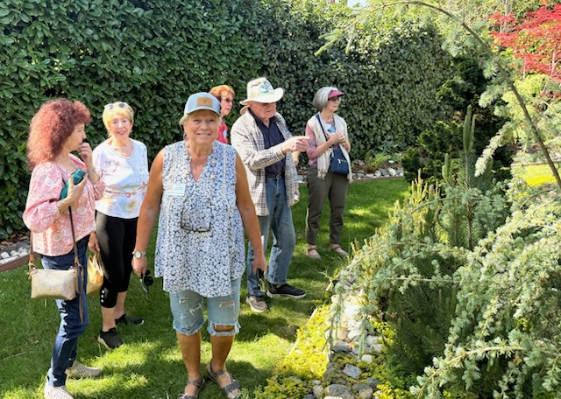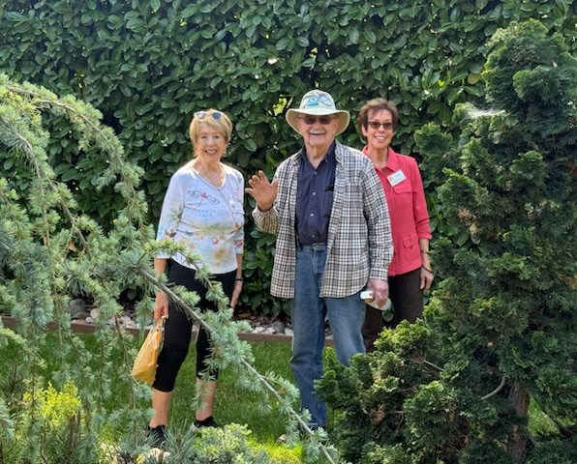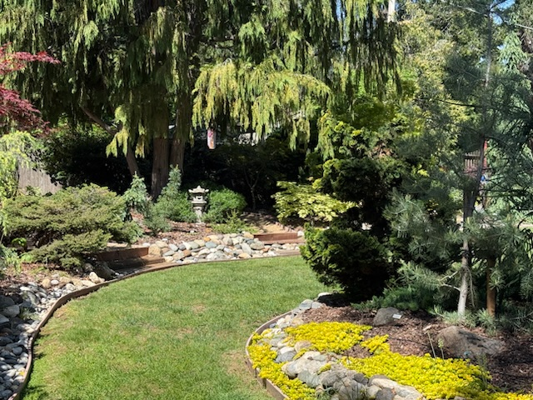





FOR YOUR INFORMATION
Please contact the NCWSC President if you would like to submit articles about local events for publication in the newsletter.
October Auction
It’s not too early to start thinking about donations for our annual auction in October, which raises funds for the Christmas Families Project. This year we will be accepting donations in the following categories:

Activity group baskets Art and collectibles
Services Gift certificates
Yard art Accessories such as purses, jewelry, scarves
and hats
When frequenting local businesses, if appropriate, ask if they might consider donating a gift certificate to our auction (salons, restaurants, retail shops, etc.). Groups might consider offering 50% of the gift certificate/service amount collected from members.

Do you have a special skill such as baking, or other cooking gift you could offer? Might you be able to donate a timeshare or B&B vacation? Are you willing to lead a local historical tour, host a game night, teach a skill, or offer any other biddable idea?

We already have a half-day of fishing on Lake Englebright, one hour of tech support from Quietech and a haircut and blow dry from Bella Villa Salon.

We will be posting donation drop off dates in future newsletters.

START COLLECTING ITEMS FOR DONATION TO THE OCTOBER AUCTION!

MEMBERSHIP NEWS
As of April 19, we have a total of 170 members!

Membership dues are $50 per year, covering January through December 2026. Members can take part in all events and activity groups and will receive the monthly newsletter. Payment for dues can be made by Zelle or by mailing a check. Please note "dues" on your payment.

Lifetime Membership: Remember when you reach that great age of 90 you are eligible to become a Lifetime Member. This means you will have your dues waived

New Member Gathering: A New Member Gathering has been scheduled for May 6 from 10:00 am to noon. We will provide an overview of the Club and its events, activities and address questions from attendees
SUNSHINE
The Sunshine Committee is dedicated to brightening the days of members who are going through tough times by sending thoughtful, personalized cards. Whether someone is facing an illness or injury, grieving a loss, or simply needs a little encouragement, the committee’s goal is to let them know they are not alone. If you know a member who would benefit from a note, please contact us with enough information to send an appropriate card.

